**Topics: Descriptive Statistics and Probability**

1. Look at the data given below. Plot the data, find the outliers and find out $μ, σ, σ^{2}$

|  |  |
| --- | --- |
| **Name of company** | **Measure X** |
| Allied Signal | 24.23% |
| Bankers Trust | 25.53% |
| General Mills | 25.41% |
| ITT Industries | 24.14% |
| J.P.Morgan & Co. | 29.62% |
| Lehman Brothers | 28.25% |
| Marriott | 25.81% |
| MCI | 24.39% |
| Merrill Lynch | 40.26% |
| Microsoft | 32.95% |
| Morgan Stanley | 91.36% |
| Sun Microsystems | 25.99% |
| Travelers | 39.42% |
| US Airways | 26.71% |
| Warner-Lambert | 35.00% |

* Above data plotted at bellow
* In this data the outlier is **Morgan Stanley measure 91.36%**

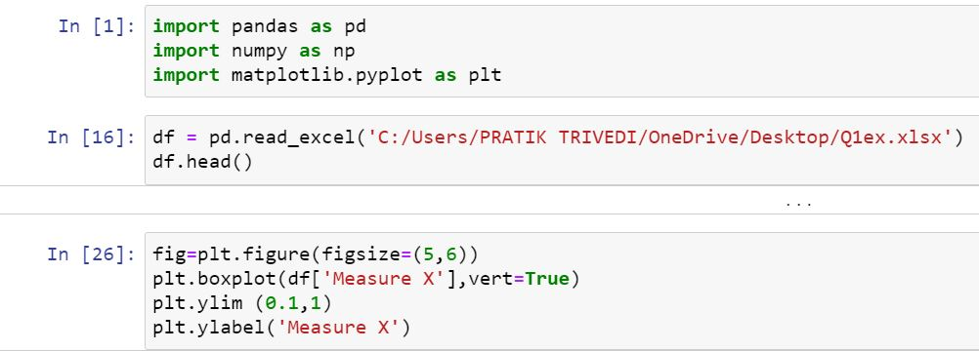

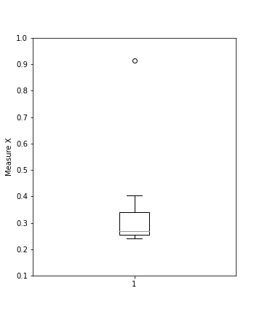

**Mean,Variance & Standard Deviation**

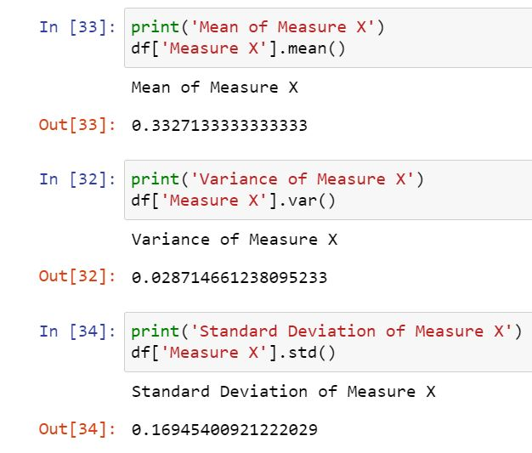



Answer the following three questions based on the box-plot above.

1. What is inter-quartile range of this dataset? (please approximate the numbers) In one line, explain what this value implies.

* In this boxplot Q1 is 5 and Q3 is approximate 12
* So the IQR = Q3-Q1

= 12-5

**IQR = 7**

1. What can we say about the skewness of this dataset?

The median of data is near by Q1 so the **Nature of skewness is Positive**

1. If it was found that the data point with the value 25 is actually 2.5, how would the new box-plot be affected?

* In this data frame the total IQR is between 5 to 12 And data frame is between 0 to 18 so if 25 is actually 2.5 so that is not consider as outlier because is this present in data frame.



Answer the following three questions based on the histogram above.

1. Where would the mode of this dataset lie?

* Mode is lie at between the **4 to 8**

1. Comment on the skewness of the dataset.

* Bell shape is at left side so the **nature of skewness is Positive**

1. Suppose that the above histogram and the box-plot in question 2 are plotted for the same dataset. Explain how these graphs complement each other in providing information about any dataset.

* Outlier is shows in boxplot.
* Skewness is shows in histogram.
* From the boxplot we can find the IQR.
* From the Histogram we find data separatly plot wise.
* From the boxplot we can find the median.
* From the histogram we can find the mode.

1. AT&T was running commercials in 1990 aimed at luring back customers who had switched to one of the other long-distance phone service providers. One such commercial shows a businessman trying to reach Phoenix and mistakenly getting Fiji, where a half-naked native on a beach responds incomprehensibly in Polynesian. When asked about this advertisement, AT&T admitted that the portrayed incident did not actually take place but added that this was an enactment of something that “could happen.” Suppose that one in 200 long-distance telephone calls is misdirected. What is the probability that at least one in five attempted telephone calls reaches the wrong number? (Assume independence of attempts.)

* In this data we make 200 calls in that call one call is wrong number, so we take randomly five calls and in this five call one call is wrong so we want to find a probability of this one call.

**=>** Total attempt = 200

Randomly selection = 5

P(x) = randomly selection/total attempt

= 5/200

=0.025 = **2.5%**

1. Returns on a certain business venture, to the nearest $1,000, are known to follow the following probability distribution

|  |  |
| --- | --- |
| x | P(x) |
| -2,000 | 0.1 |
| -1,000 | 0.1 |
| 0 | 0.2 |
| 1000 | 0.2 |
| 2000 | 0.3 |
| 3000 | 0.1 |

1. What is the most likely monetary outcome of the business venture?

* whenProbability is high it means that outcome is most so in this data highest probability is 0.3 is for x=2000. **So 2000 is most likely outcome**

1. Is the venture likely to be successful? Explain

When we get profit at that time we can say the venture is successful.

So in this data we want to find the probability of profit and loss

So

P(loss) = 0.1+0.1 P(profit) =0.2+0.3+0.1

**P(loss) = 0.2 P(profit) = 0.6**

**Here P(loss) < P(profit) Profit is high so the venture is successful**

1. What is the long-term average earning of business ventures of this kind? Explain

Total Average income = **E** x*P(x)

= {(-2000)*(0.1) + (-1000)*(0.1) + (0)*(0.2) + (1000)*(0.2) + (2000)*(0.3)

+ (3000)*(0.1) }

= { (-200) + (-100) + (0) + (200) + (600) + (300) }

**Total Average income = 800**

1. What is the good measure of the risk involved in a venture of this kind? Compute this measure

* To find the risk best measure is variance and standard deviation

